In [1]:

*# importing lib.*

**import** numpy **as** np

**import** pandas **as** pd

**import** matplotlib.pyplot **as** plt

**import** seaborn **as** sns

In [2]:

df **=** pd**.**read_csv('mymoviedb.csv', lineterminator**=**'\n') df**.**head()

Out[2]:

|  |  |  |  |  |  |  |  |
| --- | --- | --- | --- | --- | --- | --- | --- |
|  | **Release_Date** | **Title** | **Overview** | **Popularity** | **Vote_Count** | **Vote_Average** | **Original_** |
| **0** | 2021-12-15 | Spider-  Man: No Way Home | Peter Parker is unmasked  and no longer able  to... | 5083.954 | 8940 | 8.3 |  |
| **1** | 2022-03-01 | The Batman | In his second  year of fighting crime,  Batman u... | 3827.658 | 1151 | 8.1 |  |
| **2** | 2022-02-25 | No Exit | Stranded at a rest stop in  the mountains  durin... | 2618.087 | 122 | 6.3 |  |
| **3** | 2021-11-24 | Encanto | The tale of  an extraordinary family, the  Madri... | 2402.201 | 5076 | 7.7 |  |
| **4** | 2021-12-22 | The King's Man | As a collection of  history's worst tyrants  and... | 1895.511 | 1793 | 7.0 |  |

In [3]:

*# viewing dataset info*

df**.**info()

<class 'pandas.core.frame.DataFrame'> RangeIndex: 9827 entries, 0 to 9826

Data columns (total 9 columns):

# Column Non-Null Count Dtype

1. Release_Date 9827 non-null object
2. Title 9827 non-null object
3. Overview 9827 non-null object
4. Popularity 9827 non-null float64
5. Vote_Count 9827 non-null int64
6. Vote_Average 9827 non-null float64
7. Original_Language 9827 non-null object
8. Genre 9827 non-null object
9. Poster_Url 9827 non-null object dtypes: float64(2), int64(1), object(6)

memory usage: 691.1+ KB

* + looks like our dataset has no NaNs! • Overview, Original_Language and Poster-Url wouldn't be so useful during analysis • Release_Date column needs to be casted into date time and to extract only the year value

In [8]:

*# exploring genres column*

df['Genre']**.**head()

Out[8]:

In [11]:

Out[11]:

In [15]:

*# exploring summary statistics*

df**.**describe()

1. Action, Adventure, Science Fiction
2. Crime, Mystery, Thriller
3. Thriller
4. Animation, Comedy, Family, Fantasy
5. Action, Adventure, Thriller, War Name: Genre, dtype: object
   * genres are saperated by commas followed by whitespaces.

*# check for duplicated rows*

df**.**duplicated()**.**sum()

0

* + our dataset has no duplicated rows either.

|  |  |  |  |
| --- | --- | --- | --- |
|  | **Popularity** | **Vote_Count** | **Vote_Average** |
| **count** | 9827.000000 | 9827.000000 | 9827.000000 |
| **mean** | 40.326088 | 1392.805536 | 6.439534 |
| **std** | 108.873998 | 2611.206907 | 1.129759 |
| **min** | 13.354000 | 0.000000 | 0.000000 |
| **25%** | 16.128500 | 146.000000 | 5.900000 |
| **50%** | 21.199000 | 444.000000 | 6.500000 |
| **75%** | 35.191500 | 1376.000000 | 7.100000 |
| **max** | 5083.954000 | 31077.000000 | 10.000000 |

In [ ]:

* Exploration Summary
* we have a dataframe consisting of 9827 rows **and** 9 columns**.**
* our dataset looks a bit tidy **with** no NaNs nor duplicated values**.**
* Release_Date column needs to be casted into date time **and** to extract only the
* Overview, Original_Languege **and** Poster**-**Url wouldn't be so useful during analys
* there **is** noticable outliers **in** Popularity column
* Vote_Average bettter be categorised **for** proper analysis**.**
* Genre column has comma saperated values **and** white spaces that needs to be hand

In [18]:

*# Data Cleaning*

Casting Release_Date column and extracing year values

In [21]:

df**.**head()

Out[21]:

|  |  |  |  |  |  |  |  |
| --- | --- | --- | --- | --- | --- | --- | --- |
|  | **Release_Date** | **Title** | **Overview** | **Popularity** | **Vote_Count** | **Vote_Average** | **Original_** |
| **0** | 2021-12-15 | Spider-  Man: No Way Home | Peter Parker is unmasked  and no longer able  to... | 5083.954 | 8940 | 8.3 |  |
| **1** | 2022-03-01 | The Batman | In his second  year of fighting crime,  Batman u... | 3827.658 | 1151 | 8.1 |  |
| **2** | 2022-02-25 | No Exit | Stranded at a rest stop in  the mountains  durin... | 2618.087 | 122 | 6.3 |  |
| **3** | 2021-11-24 | Encanto | The tale of  an extraordinary family, the  Madri... | 2402.201 | 5076 | 7.7 |  |
| **4** | 2021-12-22 | The King's Man | As a collection of  history's worst tyrants  and... | 1895.511 | 1793 | 7.0 |  |

In [23]:

*# casting column a*

df['Release_Date'] **=** pd**.**to_datetime(df['Release_Date'])

*# confirming changes*

print(df['Release_Date']**.**dtypes)

datetime64[ns]

In [25]:

df['Release_Date'] **=** df['Release_Date']**.**dt**.**year df['Release_Date']**.**dtypes

Out[25]: dtype('int32') In [27]:

df**.**info()

<class 'pandas.core.frame.DataFrame'> RangeIndex: 9827 entries, 0 to 9826

Data columns (total 9 columns):

# Column Non-Null Count Dtype

1. Release_Date 9827 non-null int32
2. Title 9827 non-null object
3. Overview 9827 non-null object
4. Popularity 9827 non-null float64
5. Vote_Count 9827 non-null int64
6. Vote_Average 9827 non-null float64
7. Original_Language 9827 non-null object
8. Genre 9827 non-null object
9. Poster_Url 9827 non-null object

dtypes: float64(2), int32(1), int64(1), object(5) memory usage: 652.7+ KB

df**.**head()

In [29]:

Out[29]:

In [32]:

*# making list of column to be dropped*

cols **=** ['Overview', 'Original_Language', 'Poster_Url']

|  |  |  |  |  |  |  |  |
| --- | --- | --- | --- | --- | --- | --- | --- |
| **Release_Date** | | **Title** | **Overview** | **Popularity** | **Vote_Count** | **Vote_Average** | **Original_** |
| **0** | 2021 | Spider-  Man: No Way Home | Peter Parker is unmasked  and no longer able  to... | 5083.954 | 8940 | 8.3 |  |
| **1** | 2022 | The Batman | In his second  year of fighting crime,  Batman u... | 3827.658 | 1151 | 8.1 |  |
| **2** | 2022 | No Exit | Stranded at a rest stop in  the mountains  durin... | 2618.087 | 122 | 6.3 |  |
| **3** | 2021 | Encanto | The tale of  an extraordinary family, the  Madri... | 2402.201 | 5076 | 7.7 |  |
| **4** | 2021 | The King's Man | As a collection of  history's worst tyrants  and... | 1895.511 | 1793 | 7.0 |  |

# Dropping Overview, Original_Languege and Poster-Url

*# dropping columns and confirming changes* df**.**drop(cols, axis **=** 1, inplace **= True**) df**.**columns

Out[32]:

In [34]:

Out[34]:

In [37]:

**def** catigorize_col (df, col, labels):

"""

catigorizes a certain column based on its quartiles

Args:

(df)

(col)

df - dataframe we are proccesing

str - to be catigorized column's name

(labels) list - list of labels from min to max

Returns:

(df)

"""

df - dataframe with the categorized col

*# setting the edges to cut the column accordingly*

edges **=** [df[col]**.**describe()['min'],

df[col]**.**describe()['25%'],

df[col]**.**describe()['50%'],

df[col]**.**describe()['75%'],

df[col]**.**describe()['max']]

Index(['Release_Date', 'Title', 'Popularity', 'Vote_Count', 'Vote_Average', 'Genre'],

dtype='object')

df**.**head()

|  |  |  |  |  |  |  |
| --- | --- | --- | --- | --- | --- | --- |
| **Release_Date** | | **Title** | **Popularity** | **Vote_Count** | **Vote_Average** | **Genre** |
| **0** | 2021 | Spider- Man: No Way Home | 5083.954 | 8940 | 8.3 | Action, Adventure,  Science Fiction |
| **1** | 2022 | The Batman | 3827.658 | 1151 | 8.1 | Crime, Mystery,  Thriller |
| **2** | 2022 | No Exit | 2618.087 | 122 | 6.3 | Thriller |
| **3** | 2021 | Encanto | 2402.201 | 5076 | 7.7 | Animation, Comedy,  Family, Fantasy |
| **4** | 2021 | The King's  Man | 1895.511 | 1793 | 7.0 | Action, Adventure, Thriller, War |

**categorizing**  **Vote_Average column**

We would cut the Vote_Average values and make 4 categories: popular average

below_avg not_popular to describe it more using catigorize_col() function provided above.

df[col] **=** pd**.**cut(df[col], edges, labels **=** labels, duplicates**=**'drop')

**return** df

In [39]:

*# define labels for edges*

labels **=** ['not_popular', 'below_avg', 'average', 'popular']

*# categorize column based on labels and edges*

catigorize_col(df, 'Vote_Average', labels)

*# confirming changes*

df['Vote_Average']**.**unique()

Out[39]:

In [41]:

Out[41]:

In [43]:

*# exploring column*

df['Vote_Average']**.**value_counts()

['popular', 'below_avg', 'average', 'not_popular', NaN]

Categories (4, object): ['not_popular' < 'below_avg' < 'average' < 'popular']

df**.**head()

|  |  |  |  |  |  |  |
| --- | --- | --- | --- | --- | --- | --- |
| **Release_Date** | | **Title** | **Popularity** | **Vote_Count** | **Vote_Average** | **Genre** |
| **0** | 2021 | Spider- Man: No Way Home | 5083.954 | 8940 | popular | Action, Adventure,  Science Fiction |
| **1** | 2022 | The Batman | 3827.658 | 1151 | popular | Crime, Mystery,  Thriller |
| **2** | 2022 | No Exit | 2618.087 | 122 | below_avg | Thriller |
| **3** | 2021 | Encanto | 2402.201 | 5076 | popular | Animation, Comedy,  Family, Fantasy |
| **4** | 2021 | The King's  Man | 1895.511 | 1793 | average | Action, Adventure, Thriller, War |

|  |  |  |
| --- | --- | --- |
| Out[43]: | Vote_Average |  |
|  | not_popular | 2467 |
|  | popular | 2450 |
|  | average | 2412 |
|  | below_avg | 2398 |
|  | Name: count, | dtype: int64 |

In [45]:

*# dropping NaNs*

df**.**dropna(inplace **= True**)

*# confirming*

df**.**isna()**.**sum()

Out[45]:

Release_Date 0

Title 0

Popularity 0

Vote_Count 0

Vote_Average 0

Genre 0

dtype: int64

In [47]:

df**.**head()

Out[47]:

In [52]:

Out[52]:

In [55]:

*# casting column into category*

df['Genre'] **=** df['Genre']**.**astype('category')

*# confirming changes*

df['Genre']**.**dtypes

|  |  |  |  |  |  |  |
| --- | --- | --- | --- | --- | --- | --- |
| **Release_Date** | | **Title** | **Popularity** | **Vote_Count** | **Vote_Average** | **Genre** |
| **0** | 2021 | Spider- Man: No Way Home | 5083.954 | 8940 | popular | Action, Adventure,  Science Fiction |
| **1** | 2022 | The Batman | 3827.658 | 1151 | popular | Crime, Mystery,  Thriller |
| **2** | 2022 | No Exit | 2618.087 | 122 | below_avg | Thriller |
| **3** | 2021 | Encanto | 2402.201 | 5076 | popular | Animation, Comedy,  Family, Fantasy |
| **4** | 2021 | The King's  Man | 1895.511 | 1793 | average | Action, Adventure, Thriller, War |

# we'd split genres into a list and then explode our dataframe to have only one genre per row for ezch movie

*# split the strings into lists*

df['Genre'] **=** df['Genre']**.**str**.**split(', ')

*# explode the lists*

df **=** df**.**explode('Genre')**.**reset_index(drop**=True**) df**.**head()

|  |  |  |  |  |  |  |
| --- | --- | --- | --- | --- | --- | --- |
| **Release_Date** | | **Title** | **Popularity** | **Vote_Count** | **Vote_Average** | **Genre** |
| **0** | 2021 | Spider-Man: No  Way Home | 5083.954 | 8940 | popular | Action |
| **1** | 2021 | Spider-Man: No  Way Home | 5083.954 | 8940 | popular | Adventure |
| **2** | 2021 | Spider-Man: No  Way Home | 5083.954 | 8940 | popular | Science Fiction |
| **3** | 2022 | The Batman | 3827.658 | 1151 | popular | Crime |
| **4** | 2022 | The Batman | 3827.658 | 1151 | popular | Mystery |

Out[55]:

CategoricalDtype(categories=['Action', 'Adventure', 'Animation', 'Comedy', 'Cri me',

'Documentary', 'Drama', 'Family', 'Fantasy', 'History',

'Horror', 'Music', 'Mystery', 'Romance', 'Science Fiction', 'TV Movie', 'Thriller', 'War', 'Western'],

, ordered=False, categories_dtype=object)

In [57]:

df**.**info()

<class 'pandas.core.frame.DataFrame'> RangeIndex: 25552 entries, 0 to 25551 Data columns (total 6 columns):

# Column Non-Null Count Dtype

1. Release_Date 25552 non-null int32
2. Title 25552 non-null object
3. Popularity 25552 non-null float64
4. Vote_Count 25552 non-null int64
5. Vote_Average 25552 non-null category
6. Genre 25552 non-null category

dtypes: category(2), float64(1), int32(1), int64(1), object(1) memory usage: 749.6+ KB

In [59]:

df**.**nunique()

Out[59]:

In [62]:

*# setting up seaborn configurations*

sns**.**set_style('whitegrid')

Release_Date 100

Title 9415

Popularity 8088

Vote_Count 3265

Vote_Average 4

Genre 19

dtype: int64

Now that our dataset is clean and tidy, we are left with a total of 6 columns and 25551 rows to dig into during our analysis

# Data Visualization

here, we'd use Matplotlib and seaborn for making some informative visuals to gain insights abut our data.

# Q1: What is the most frequent genre in the dataset?

In [65]:

*# showing stats. on genre column*

df['Genre']**.**describe()

Out[65]:

In [67]:

count 25552

unique 19

top Drama

freq 3715

Name: Genre, dtype: object

*# visualizing genre column*

sns**.**catplot(y **=** 'Genre', data **=** df, kind **=** 'count', order **=** df['Genre']**.**value_counts()**.**index, color **=** '#4287f5')

plt**.**title('genre column distribution') plt**.**show()

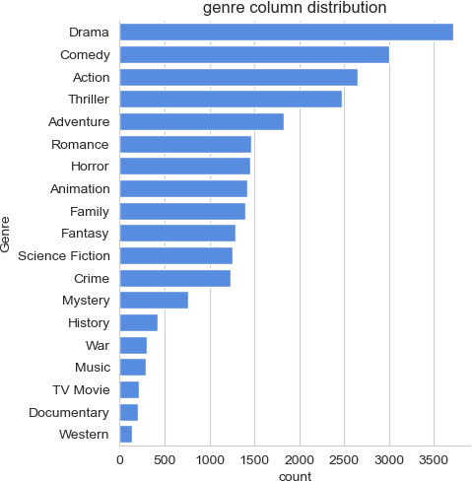

 we can notice from the above visual that Drama genre is the most frequent genre in our dataset and has appeared more than 14% of the times among 19 other

genres.

### Q2: What genres has highest votes ?

In [71]:

*# visualizing vote_average column*

sns**.**catplot(y **=** 'Vote_Average', data **=** df, kind **=** 'count', order **=** df['Vote_Average']**.**value_counts()**.**index, color **=** '#4287f5')

plt**.**title('votes destribution') plt**.**show()

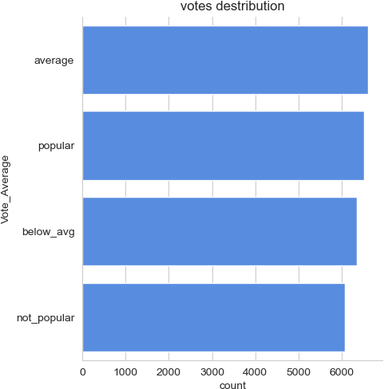

### Q3: What movie got the highest popularity ? what's its

### genre ?

In [74]:

*# checking max popularity in dataset*

df[df['Popularity'] **==** df['Popularity']**.**max()]

Out[74]:

In [86]:

*# checking max popularity in dataset*

df[df['Popularity'] **==** df['Popularity']**.**min()]

|  |  |  |  |  |  |  |
| --- | --- | --- | --- | --- | --- | --- |
| **Release_Date** | | **Title** | **Popularity** | **Vote_Count** | **Vote_Average** | **Genre** |
| **0** | 2021 | Spider-Man: No Way Home | 5083.954 | 8940 | popular | Action |
| **1** | 2021 | Spider-Man: No Way Home | 5083.954 | 8940 | popular | Adventure |
| **2** | 2021 | Spider-Man: No Way Home | 5083.954 | 8940 | popular | Science Fiction |

## Q4: What movie got the lowest popularity? what's its genre?

Out[86]:

|  |  |  |  |  |  |  |
| --- | --- | --- | --- | --- | --- | --- |
| **Release_Date** | | **Title** | **Popularity** | **Vote_Count** | **Vote_Average** | **Genre** |
| **25546** | 2021 | The United States vs.  Billie Holiday | 13.354 | 152 | average | Music |
| **25547** | 2021 | The United States vs.  Billie Holiday | 13.354 | 152 | average | Drama |
| **25548** | 2021 | The United States vs.  Billie Holiday | 13.354 | 152 | average | History |
| **25549** | 1984 | Threads | 13.354 | 186 | popular | War |
| **25550** | 1984 | Threads | 13.354 | 186 | popular | Drama |
| **25551** | 1984 | Threads | 13.354 | 186 | popular | Science Fiction |

## Q5: Which year has the most filmmed movies?

In [82]:

df['Release_Date']**.**hist()

plt**.**title('Release_Date column distribution') plt**.**show()

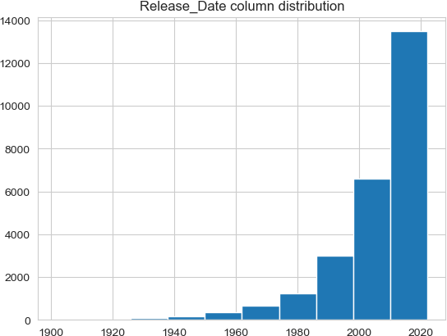

## Conclusion

#### Q1: What is the most frequent genre in the dataset?

Drama genre is the most frequent genre in our dataset and has appeared more than 14% of the times among 19 other genres.

#### Q2: What genres has highest votes ?

we have 25.5% of our dataset with popular vote (6520 rows). Drama again gets the

highest popularity among fans by being having more than 18.5% of movies popularities.

#### Q3: What movie got the highest popularity ? what's its genre ?

Spider-Man: No Way Home has the highest popularity rate in our dataset and it has genres of Action , Adventure and Sience Fiction .

#### Q3: What movie got the lowest popularity ? what's its genre ?

The united states, thread' has the highest lowest rate in our dataset and it has genres of music , drama , 'war', 'sci-fi' and history`.

#### Q4: Which year has the most filmmed movies?

year 2020 has the highest filmming rate in our dataset.

In [ ]: